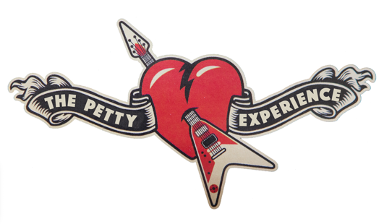

THE PETTY EXPERIENCE - BIOGRAPHY

The Petty Experience is the premier tribute to Tom Petty and the Heartbreakers. The band puts on a world-class show featuring tracks by the Heartbreakers, Tom’s solo works, The Traveling Wiburys and
some of Tom’s favorite artists.

Based in St Petersburg Florida, the Experience’s members are all incredible players and have played around the world from the US and Canada to the UK and Australia. Together they’re a formidable force. Shows are high energy, audience participatory and all-round fun.

Davy Alder: Lead Vocals, Guitar, Harmonica
Originating from Newcastle, UK, Davy has performed across the globe including shows in London Amsterdam, Los Angeles, Nashville, San Francisco and Perth, Australia. He’s a Petty fanatic and seen 36 shows across three continents starting in 1982. As well as being an extremely accomplished vocalist, he’s also a veteran of the music industry, worked with top producers and opened for major acts.

Bobby Boos - Drums, Percussion, Back Up Vocals

Originally a native of Seattle, Bobby moved to Los Angeles in the 1980’s and quickly became part of its
vibrant music scene. As a professional musician he’s toured America for over 15 years playing in 1,500 to
17,000 seat venues opening for huge acts including Journey, REO Speedwagon, Night Ranger, Jefferson
Starship, Rick Derringer, Foghat and Eddie Money.

Jason Perry - Lead Guitar
From Norway, Maine, Jason has spent years playing in bands across the US and Canada. Today he spends endless days perfecting Mike Campbell’s riffs down to the last detail. He’s a veteran of the tribute scene playing in many quality outfits including Judas Sabbath, the acclaimed Black Sabbath/ Judas Priest band.

Chris Thomas – Keyboards, Back Up Vocals, Acoustic Guitar
Hailing from Kentucky, Chris began singing and playing piano in his father's small-town church. Since then, he’s performed with or opened for up for rock and country headline acts including Gin Blossoms, Foghat, Dixie Chicks, Keith Urban and Delbert McClinton, Restless Heart, Wynona Judd and Sawyer Brown.

Scott Collins - Bass Guitar, Back Up Vocals

Bostonian Scott honed his craft on stages across the United States. He’s performed with or opened for many major acts including Cheap Trick, The Black Crowes, Garth Brooks, No Doubt, Oasis, Bush, X, Blur and The Flaming Lips. Tom Petty has been a musical staple throughout Scott's life, and he spends endless days perfecting the musical nuances of the Heartbreakers’ Ron Blair and Howie Epstein.

